

National College of Ireland

<Academic Year i.e. 2020/2021>

**<Eskandar>, <23137517>,** [**<x23137517@student.ncirl.ie**](mailto:%3cx23137517@student.ncirl.ie)**>**

**<Alex>, <22440482>,** [**<x22440482@student.ncirl.ie**](mailto:%3cx22440482@student.ncirl.ie)**>**

**<Joshua>, <23153920>,** [**<x23153920@student.ncirl.ie**](mailto:%3cx23153920@student.ncirl.ie)**>**

**<Yonas>, <23154454>, <x23154454@student.ncirl.ie>**

**<**[**Market-Live-Prices-Team-Project**](https://github.com/EskandarAtrakchi/Market-Live-Prices-Team-Project) **>**

Technical Report

Contents

Executive Summary 2

1.0 Introduction 2

1.1. Background 2

1.2. Aims 2

1.3. Technology 2

2.0 System 2

2.1. Requirements 2

2.1.1. Functional Requirements 2

2.1.1.1. Use Case Diagram 3

Main 4

Feedback 4

ID Retrieval 6

Public Chat 8

Requirement 1 <Crypto ID Retrieval> 8

Scope 9

Description 9

Flow Description 9

Precondition 9

Activation 9

Main flow 9

Alternate flow 9

Exceptional flow 9

Termination 9

Post condition 9

Requirement 2 <Crypto Bubbles> 10

Scope 10

Description 10

Flow Description 10

Precondition 10

Activation 10

Main flow 10

Alternate flow 10

Exceptional flow 10

Termination 11

Requirement 3 <Fear and Greed index> 11

Scope 11

Description 11

Flow Description 11

Precondition 11

Activation 11

Main flow 11

Alternate flow 11

Exceptional flow 11

Termination 11

Post condition 11

Requirement 4 <User Public Chat> 12

Description 12

Flow Description 12

Precondition 12

Activation 12

Main flow 12

Alternate flow 12

Exceptional flow 12

Termination 12

Post condition 12

Requirement 5 < Price Retrieval > 13

Description & priority 13

Use Case 13

Scope 13

Description 13

Flow Description Precondition 13

Activation 13

Main Flow 13

Alternate Flow (A1) 13

Exceptional flow (E1) 13

Requirement 6 Feedback 13

Scope 14

Description 14

Flow Description 14

Precondition 14

Activation 14

Main flow 14

Alternate flow 14

Exceptional flow 14

Termination 14

Post condition 14

2.1.2. Data Requirements 15

Description 15

2.1.2.1 Data Requirements of Ticker page 15

2.1.2.2 Data Requirements of Feedback page 15

2.1.3. User Requirements 15

Description 15

2.1.4. Environmental Requirements 16

Description 16

2.1.5. Usability Requirements 16

Description 16

2.2. Design & Architecture 16

2.3. Implementation 17

2. Frontend 17

2.4. Graphical User Interface (GUI) 18

2.5. Testing 20

3.0 Further Development 21

4.0 References 21

5.0 Appendices 21

5.1. Collaboration Summary 21

# Executive Summary

This technical report document will be detailed by the team knowing that each team member did their part on the document. This document is subject to change if the team decides to make modifications/changes to the product.

The report's main goal is to highlight the group project, what the team has created, the technology used in development, and the overall architecture or structure of the project.

We will define the aim, system mechanism used, codes, and requirements.

The testing results will be published alongside the conclusion.

# Introduction

## Background

The blockchain technology is evolving every single day and its growing at an unprecedented speed, the crypto market is earning 2.8 trillion dollars at the time of writing this document.

## Aims

Our aim is to enter the industry by providing user services, as the market is volatile trades. Anyone on earth who wants to know the prices of cryptocurrencies could just visit our website.

## Technology

We have used the following technologies:

|  |  |
| --- | --- |
| **Frontend** | **Backend** |
| HTML | Express.js |
| CSS | CORS.js |
| Bootstrap | Nodemon |
| JavaScript | Node.js |
| Chart.js | Socket.io |
| Integrity SHA-384 Decryption | Origins |
| CORS Origins | SHA-384 Encryption |
| HTTPS | Axios |
| jQuery | HTTPS |
| Local-Storage | Local-Storage |

# System

## Requirements

The system targets those who want real-time information without the need for registration of their private details. A feedback mechanism will be implemented to take it fully from user’s perspective and see what the market requires.

Description: Users should be able to receive real-time updates on the prices of selected cryptocurrencies. The system must provide accurate and up-to-date information, including the current market price in US dollars.

Rationale: Individual investors and traders need timely information to make informed decisions. Real-time updates ensure that users have the latest data to react to market changes promptly. The users should be able to retrieve crypto ID numbers with the same name of cryptocurrency from the crypto market. Users can see the frame of crypto bubbles from the webpage.

## Functional Requirements

This section lists the functional requirements in **ranked order**. Functional requirements describe the possible effects of a software system, in other words, what the system must accomplish. Other kinds of requirements (such as interface requirements, performance requirements, or reliability requirements) describe how the system accomplishes its functional requirements. Each functional requirement should be specified in a format similar to the following:

Short, imperative sentence stating highest ranked functional requirement.

## Use Case Diagram

## Main

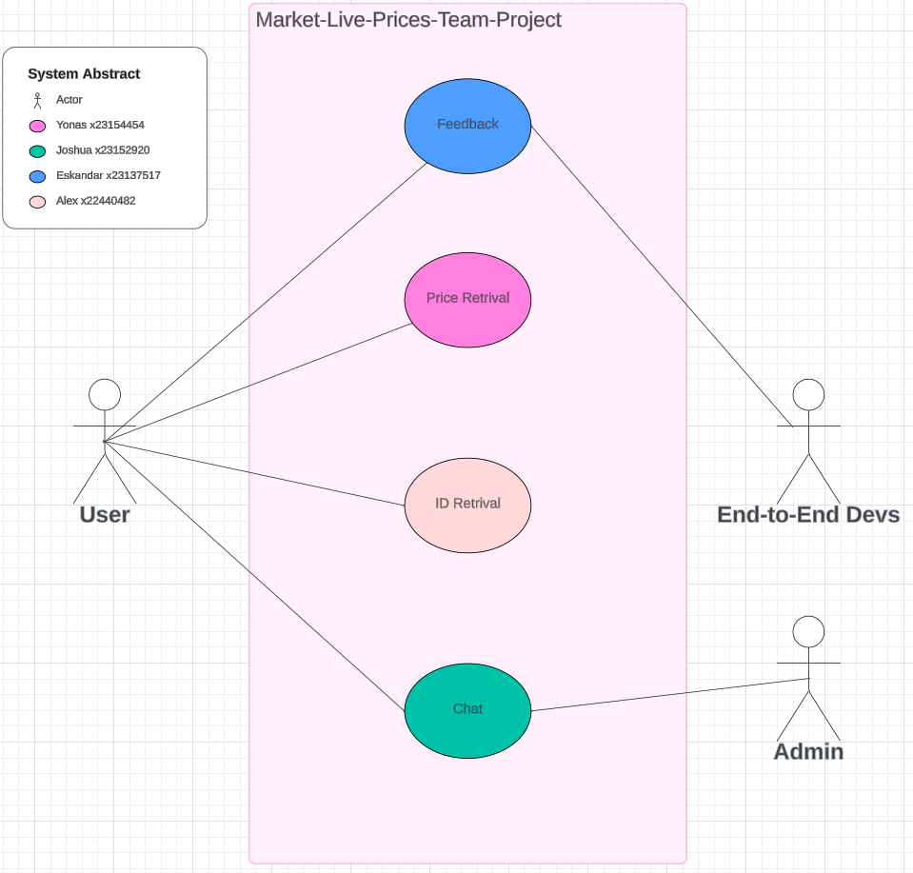

Overall system abstract

## Feedback

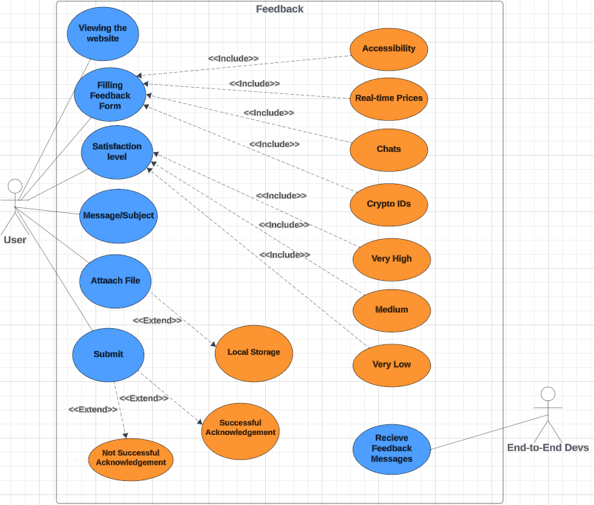

Eskandar Use case Diagram

1. Viewing the website: after the user interacts with the product, they can submit their feedback form.
2. Filling feedback form: the user will be prompt to a form to fill and submit, with in the form the user must choose one of the following categories: Accessibility, Real-time Prices, Chats, and Crypto IDs
3. Message/subject: to fill out a message attached with the feedback.
4. Satisfaction level: the user can select very high, medium, or very low.
5. Attach file: the user will be able to to select a file from their local storage.
6. Submit: the user will submit their feedback and an acknowledgement will be sent

Price Retrieval

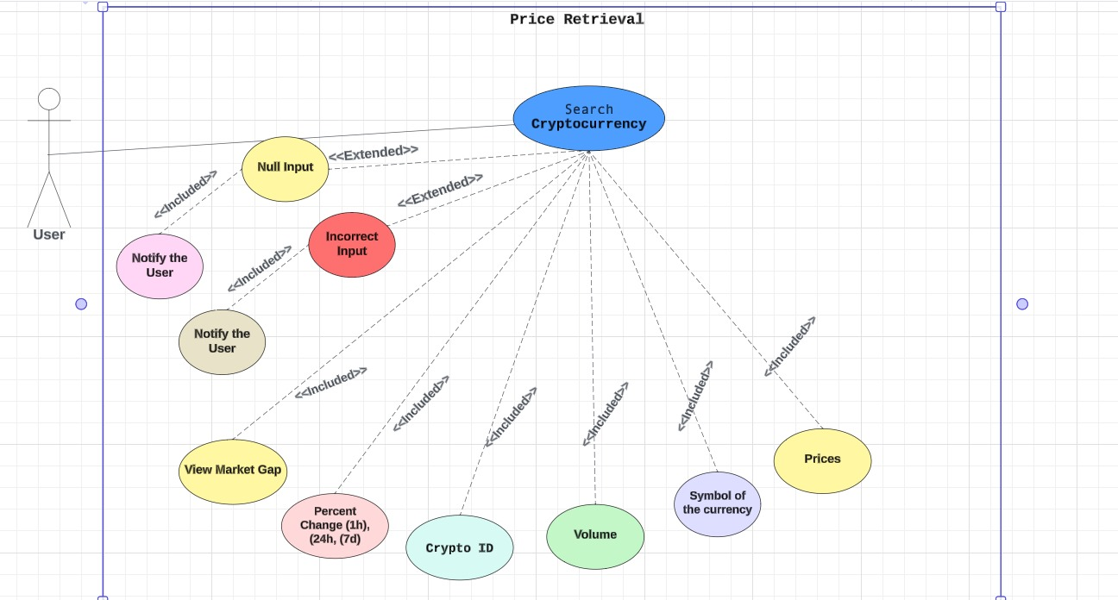

Yonas Use case Diagram

1. The user will interact with the website page to search crypto prices using the name.
2. If the user input null or wrong input the system will inform them to try again with correct information.
3. If the user input correct information the system will fetch the data with expected functionality.

## ID Retrieval

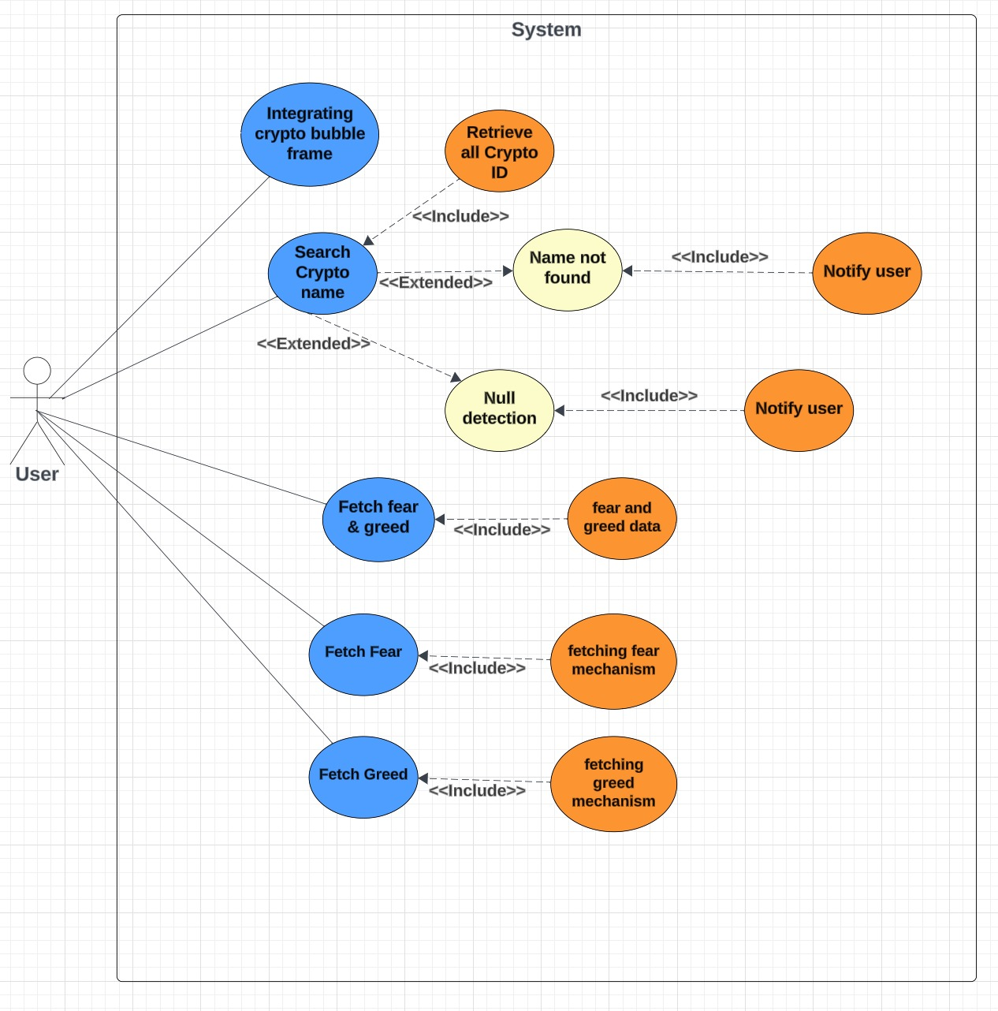

The ID number retrieval for any cryptocurrency that exists in the crypto market, the API will retrieve the ID number of the cryptocurrency, and the reason for this is because the smaller the ID number of the cryptocurrency the more data about the prices of the currency that we have.

## Public Chat

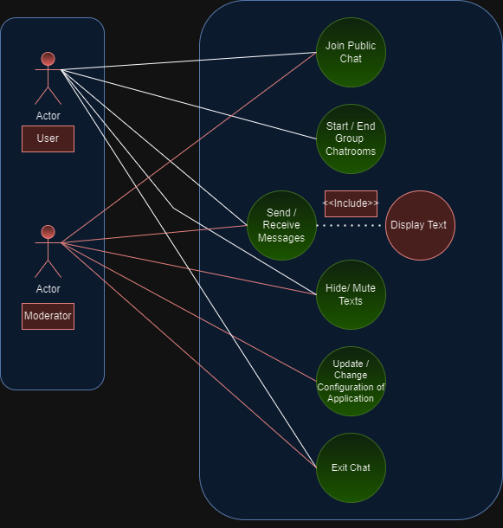

1.User joins public chat.

2.User has an option in starting or ending a group chat (private room) where you can text selected users.

3.User sends and receives messages to other users, which gets displayed. onto the public chat.

4.User can hide text (delete) his own text message if need be.

5.Developer can update, modify, and delete the software of the chat application.

6.User can exit chat.

# Requirement 1 <Crypto ID Retrieval>

#### Description & Priority

Requirements describing the Retrieving crypto ID from which users can search with, the user enters the name of the cryptocurrency and receives information about it. This is a crucial function for our website as it's our main theme of subject to provide users with real-time information about crypto.

#### Use Case

1. Search crypto currency price via name

2. Retrieve all crypto data id, symbol, price and volume

3. Error detection, name not found, null

## Scope

The scope of this use case is to allow users to retrieve the ID number by using API for any cryptocurrency that exists in the crypto market.

## Description

This use case describes the ID number that refers to the ID listing. For that reason, for any type of cryptocurrency with the same name, all crypto IDs will be retrieved and the bar charts will compare the smaller ID number of the cryptocurrency the higher prices of the currency that we have.

## Flow Description

## Precondition

The system is in initialisation mode, ready to receive the ID number from the crypto market

## Activation

This use case starts when a user enters a textbox to retrieve the ID numbers of a cryptocurrency.

## Main flow

1. The system identifies the crypto IDs that will be retrieved.
2. The user enters the crypto name in the textbox to retrieve the crypto ID of the cryptocurrency.
3. The system retrieves all crypto IDs that will be associated with cryptocurrency from the crypto market
4. The user receives the crypto IDs from the API system.

## Alternate flow

A1 : < Crypto Name Not Found>

1. The system fails to find cryptocurrency
2. The user receives an error message
3. The use case continues at position 3 of the main flow

## Exceptional flow

E1 : <System Error>

1. The system notifies the developers of an unexpected error when the crypto ID is retrieved.
2. The user receives the error message
3. The use case continues at position 4 of the main flow

## Termination

The system presents the next of crypto IDs with bar charts.

## Post condition

The system goes into a wait state, ready to process the API to retrieve the data.

# Requirement 2 <Crypto Bubbles>

#### Description & Priority

The requirements describe the bubbles' function within the website, its role is to display all the currently used crypto as clickable bubbles that users can access where they can view its current data or past data by being able to see the crypto chart, price, information throughput each day, week, month and year. The priority of this function is the most important as it is the main purpose of our website being able to provide users with current crypto trends. The bubbles will be displayed alongside the fear and greed fetcher.

#### Use Case

Each requirement should be uniquely identified with a sequence number or a meaningful tag of some kind.

1. Integrating bubble frame

2. Search crypto name

3. Retrieve all crypto data

4. Error detection, name not found

5. Error detection, null

6. Fetch fear and greed chart

7.Fetch fear

8. Fetch greed

## Scope

The scope of this use case is to integrate cryptocurrency bubbles on the webpage.

## Description

This use case describes the process of retrieving cryptocurrencies and display the crypto bubbles on the webpage.

## Flow Description

## Precondition

The system is in initialization mode using API to retrieve cryptocurrencies.

## Activation

This use case starts when a user searches for cryptocurrency from crypto bubbles.

## Main flow

1. The system identifies the API to fetch crypto bubbles.
2. The user integrates with the crypto bubbles.
3. The system retrieves the cryptocurrency data from the API.
4. The user views the crypto bubbles from the webpage.

## Alternate flow

A1 : <Failed to display>

1. The system fails to display the crypto bubbles on the webpage
2. The user receives an error message.
3. The use case continues at position 3 of the main flow

## Exceptional flow

E1 : <title of E1>

1. The system notifies the developers of an unexpected error when the crypto bubbles is not displayed on the webpage
2. The user receives the error message
3. The use case continues at position 4 of the main flow

## Termination

The system presents the next crypto bubbles to the user.

**Post condition**

The system goes into a wait state, ready to process the API to retrieve the data.

# Requirement 3 <Fear and Greed index>

#### Description & Priority

The requirements describe the fear and greed function inside the website, its goal is to provide users with an investor sentiment regarding the crypto market ranging from 0 extreme fear to 100 to extreme greed which our website displays as an arrow chart that users can click on and see. The priority of this function is optionable, but still important to give a full view of the crypto market

#### Use Case

1. Click retrieve fear and greed index
2. Retrieve fear chart
3. Retrieve greed chart

## Scope

The scope of this use case is to retrieve the Fear and Greed index from the crypto market.

## Description

This use case describes the process of displaying the Fear and Greed index on the webpage.

## Flow Description

## Precondition

The system is in initialisation mode, the API is ready to retrieve the Fear and Greed index.

## Activation

This use case starts when a user retrieves the Fear and Greed index chart from API.

## Main flow

1. The system identifies the API to fetch the Fear and Greed index.
2. The user integrates with the Fear and Greed index.

## Alternate flow

1. A1 : <title of A1>
2. The system fails to display the Fear and Greed index on the webpage
3. The user receives the error message.
4. The use case continues at position 3 of the main flow

## Exceptional flow

E1 : <title of E1>

1. The system notifies the developers of an unexpected error when the Fear and Greed index is not displayed on the webpage
2. The user receives the error message
3. The use case continues at position 4 of the main flow

## Termination

The system presents the next Fear and Greed index to the user.

## Post condition

The system goes into a wait state.

# Requirement 4 <User Public Chat>

#### Description & Priority

Description of the chat function requirements. A separate web page that users can access, where they can interact with each other using a live server and text-inputted messages that they can like by double clicking, the number of users within the chat will be displayed on the top right. Likewise, the bubbles page also includes the chat. This function is essential for users to be able to share their opinions or the latest news on crypto to make our website more alive and more universal in use.

#### Use Case

1. Join chat room

2. Enter name

3. Send messages

4. Exit Chat

**Scope**

The scope of this use case is to provide a user public chat where people can interact and give each other their opinions.

## Description

This use case describes the public chat that will appear on the website.

## Flow Description

## Precondition

The server is running

The system is in initialisation mode when user enters the website and joins chat.

## Activation

This use case starts when the user sends a message within the public chat.

## Main flow

The normal flow

1. The system identifies the user.
2. The user is able to send and receive messages.

## Alternate flow

What happens if it goes the opposite as intended.

1. The system does not let the user join.
2. The user isn’t able to send messages or receive them.

## Exceptional flow

1. The system notifies the user of chat errors.
2. The user can restart the webpage/
3. The use case continues at position 4 of the main flow

## Termination

The system presents the next sent message or exits the public chat.

## Post condition

The system goes into a wait state

# Requirement 5 < Price Retrieval >

## Description & priority

Searching crypto data and prices: user will be able to search the cryptocurrency by searching the name of the crypto, and if they user input the correct name of the currency the system will display the crypto data.

## Use Case

1. Search crypto currency price via name

2. Retrieve all crypto data id, symbol, price and volume

3. Error detection, name not found, null

## Scope

The scope of this use case is to enable users to retrieve cryptocurrency data and prices through a search functionality.

## Description

This use case describes how users can search for cryptocurrency data and prices by entering the name of the cryptocurrency they are interested in. The system will then display the relevant data for the searched cryptocurrency.

## Flow Description Precondition

The system is initialized and has access to real-time cryptocurrency data.

## Activation

This use case starts when a user triggers the search functionality by entering the name of a cryptocurrency.

## Main Flow

1. The system identifies the user's input as a search query for cryptocurrency data.
2. The system validates the user's input to ensure it matches the name of an existing cryptocurrency.
3. If the user input matches the name of a cryptocurrency:
   * The system retrieves the relevant data and prices for the searched cryptocurrency.
   * The system displays the cryptocurrency data to the user.

## Alternate Flow (A1)

If the user input does not match the name of any existing cryptocurrency:

1. The system notifies the user that the entered cryptocurrency name is not recognized.
2. The system prompts the user to enter a valid cryptocurrency name.
3. The use case continues at position 2 of the main flow.

## Exceptional flow (E1)

If there is an error retrieving cryptocurrency data:

1. The system displays an error message indicating that cryptocurrency data could not be retrieved.
2. The system prompts the user to try again later or contact support for assistance.
3. The use case continues at position 2 of the main flow.

# Requirement 6 Feedback

#### Description & Priority

Priority is the lowest however, Feedback mechanism is very important for us to meet the user experience and for system evolution in the future to add more functionalities to the website, feedback will release the product potential if the feedback taken seriously.

The environment that we are working on is volatile especially dealing with crypto currencies, attention to user feedback is important.

#### Use Case

After the user view the website, the user can submit their feedback as the following:

1.The user can select the section that they want to submit their feedback form for, and the sections are: Accessibility, real-time prices, chats, and crypto IDs

2.Satisfaction level: there are three levels scale, and they are: very high, medium, and very low

3.Attach file: if the user wants to attach file from their local device, for example the user can take a screenshot for the meant part and submit it with their feedback process.

4.Subject: the user can write a message if they want to.

5.The team will receive the feedback that was submitted by the user to develop the product accordingly.

## Scope

The scope of this use case is to provide feedback mechanism for the users to keep developing the system for better user experience and future system evolution.

## Description

This use case describes the process of collecting and processing feedback from users regarding a particular feature or functionality within the system.

## Flow Description

## Precondition

The system is in initialization mode, ready to receive feedback from users.

## Activation

This use case starts when a user initiates the feedback process.

## Main flow

1. The system identifies the specific area or feature for which feedback is being provided.
2. The user shares their feedback and provides relevant details.
3. The system processes the feedback, recording relevant information for analysis.
4. The user receives acknowledgment or confirmation of their submitted feedback.

## Alternate flow

1. The system encounters a specific condition in which additional steps are required.
2. The user follows the specified steps to address the condition.
3. The use case continues at position 3 of the main flow.

## Exceptional flow

1. The system encounters an exceptional condition that requires special handling.
2. The user follows the prescribed steps to resolve the exceptional condition.
3. The use case continues at position 4 of the main flow.

## Termination

The system presents the next steps or information relevant to the feedback process to terminate.

## Post condition

The system transitions into a wait state, ready to receive further feedback.

1. The feedback system should provide a user-friendly interface for input.
2. The system able to capture files and include them with the submission.
3. Feedback of the users will be stored for future system evolution.
4. The acknowledgment to the user may include a reference number for tracking purposes.

## Data Requirements

Description

1. API started
2. Socket.io server started
3. Chat name entered
4. Chat message input entered
5. Search name entered

## 

## 2.1.2.1 Data Requirements of Ticker page

1. **API Endpoint**: You need an API endpoint to fetch ticker data. The endpoint should return JSON data containing information about various cryptocurrencies.
2. **Cryptocurrency Information**: The ticker data should include details about each cryptocurrency, such as: Name, Symbol, ID, Price in USD, 24-hour trading volume in USD, Market capitalization in USD, Percentage change in price over 1 hour, Percentage change in price over 24 hours, Percentage change in price over 7 days, Timestamp of the last update
3. **User Input**: Users should be able to input the symbols of cryptocurrencies they want to see data for.
4. **Error Handling**: handle cases where no data is found for a given cryptocurrency symbol.
5. **Display Format**: The fetched ticker data should be displayed in both tabular and graphical formats.

## 2.1.2.2 Data Requirements of Feedback page

1. The user needs to select from the drop-down menu what is the feedback category is about

2. The user will select from the radio buttons to select the satisfaction level

3. The user will fill out a message and then can choose any document to attach

4. The user can submit the feedback and the system will be responsive accordingly

5. If the user has already submitted their feedback before then the system will reject their feedback otherwise their feedback will be taken

## User Requirements

## Description

Outlines the user requirements for the website

1. The server must be running
2. The website page is opened
3. To access chat the user must enter his name
4. To access data id, you must search for it
5. To access bubbles, you must click on it
6. To access fear and greed index users need to click on it
7. To access feedback users, need to click on it
8. To access settings users, need to click on it

## Environmental Requirements

## Description

Outlines the environmental requirements

1. Operating System: any operating system is accessible as the project has been tested on all systems from mobiles, tablets, to computers and laptops.
2. Any device with internet connection and reasonable speed will be able to run the project
3. Unbroken device, just a device with reasonable functioning input and output will be able to run the program
4. For security and privacy reasons, the project has blocked all third parties' cookies so that the user data won't be taken from the user without the user knowledge
5. Web Browser Compatibility: any browser runs HTML 5
6. Network Connectivity: any reasonable internet connection data

## Usability Requirements

## Description

1. The project can be used on any operating system as it has been tested on several operating systems such as (Windows, Mac, and Linux) also the project is phone responsive which means that the project has been tested on several mobile systems as well, such as, Android and Iphone
2. The project is powered by several up-to-date technologies ensuring that the user end with no hustle in order to use the project. Check technology used section for more details.
3. To access the websie you just need internet connection and a browser, any browser that runs HTML 5 would be functionable to run the project
4. Responsive Design: the project has been tested on different devices with different screen to ensure that the project is usable whatever device the user uses to access the project (mobiles, tablets, and laptops)
5. Search and Filter Functionality: the website has searching functionalities for Ticker page and ID search page as the website will retrieve the data and display it to the user in real time
6. Chart Interactivity: terminal will be open for real time chat broadcasting, these functionalities will make the user to encage with the website which will make them spend longer time on the website and that’s our goal in the first place.

## Design & Architecture

The hub is back-end server responsible on routes and does the following

* if the user is trying to use chat terminal, then the route will direct the user to broadcasting via terminal to all connected devices
* if the user trying to pull data that requires APIs to execute the condition the API requests route will be directed to the APIs third party providers: this can help to get crypto listings IDs, real-time prices, changes in prices and much more.
* if the user tries to send feedback the one time condition will be implemented before routing and it works like this: A. if this is the first time that the user sends their feedback then the feedback message will be sent to the hub and an acknowledgement will be sent to the user B. if the user submitted their feedback before then the feedback mechanism system will detect that the user has submitted their feedback before therefore, their feedback will not be send to the hub and an acknowledgement will be sent to the user.

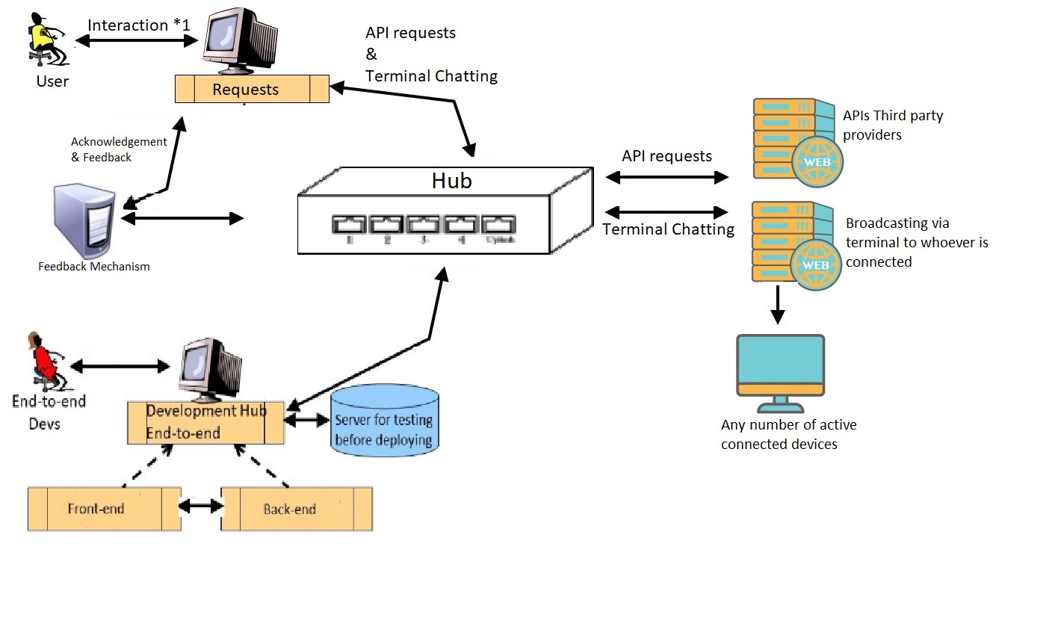

## Implementation

Describe the main algorithms/classes/functions used in the code. Consider showing and explain interesting code snippets where appropriate.

1. Backend

* Set up server-side infrastructure using a backend framework or platform using Node.js
* Implement routes or endpoints to handle incoming requests from the frontend.
* Integrate with external APIs to fetch cryptocurrency data based on user requests.

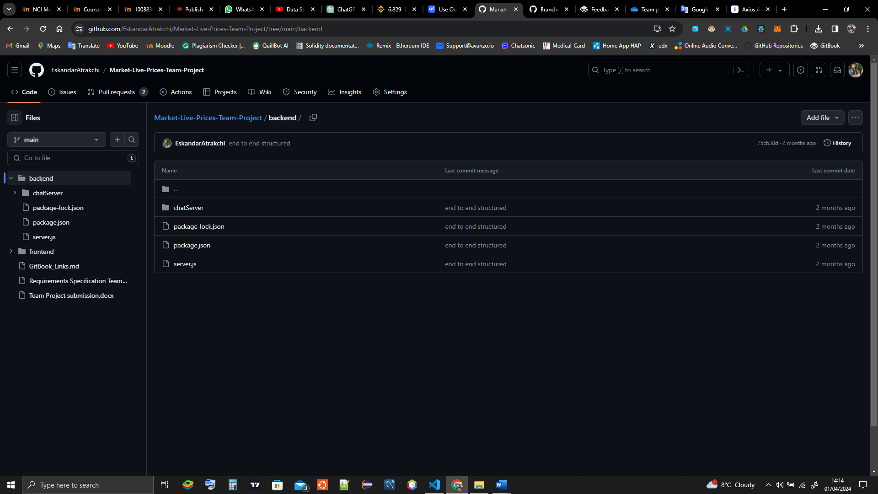

The backend is running on two servers the first server is for the API price retrievals and the second server is for the chat message broadcasting, each server has its own dependencies formatted in JSON file just like this

{

    "dependencies": {

      "axios": "^1.6.7",

      "cors": "^2.8.5",

      "express": "^4.18.2",

      "http": "^0.0.1-security",

      "nodemon": "^3.1.0"

    }

}

This will allow the program to know what we are using instead of loading the project with a lot of files which will make the project slow down to the level might not even be useable!

1. Frontend

* user interface components using HTML, CSS, and JavaScript
* Implemented the search input field to allow users to input cryptocurrency symbols.
* Develop functionality to fetch data from external APIs based on user input.
* Display fetched data in a tabular format, allowing users to view cryptocurrency details such as price, volume, market cap, etc.
* Integrate charting libraries such us Chart.js to visualize cryptocurrency data in charts or graphs.

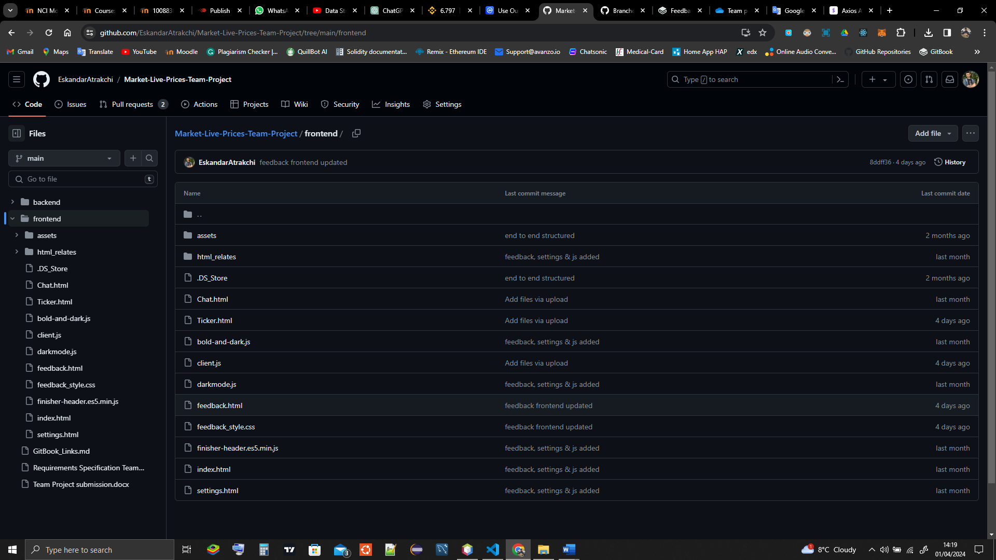

This is the structure of the frontend.   
We have used bootstrap and chart.js for dynamic chart rendering

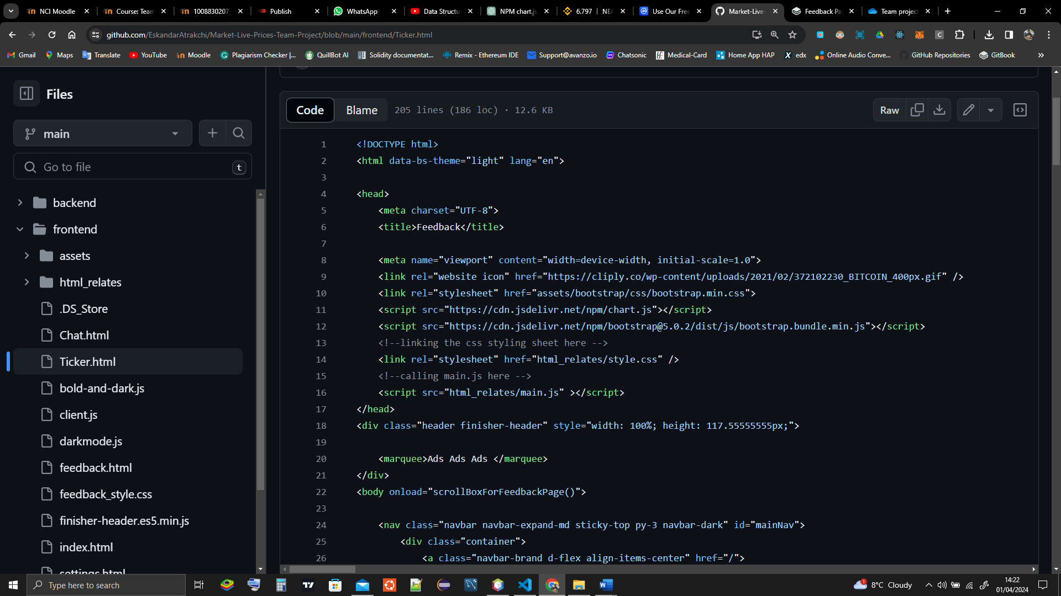  
  
the purpose of bootstrap is to handle the webpages in different screen sizes and for better styling library.  
The frontend can run on GitHub pages or any server, we might deploy it on GitHub pages when it is finished.

## Graphical User Interface (GUI)



Feedback page

The navbar is to route the user to other pages, we will include nice footer for the user that includes useful links so that the user can get more information about the markets, all pages are linked as the user can chat about crypto currencies, check the market status or specific currency, chats, and send categorized feedback.

The price retrieval GUI will be designed with a clean and intuitive layout, ensuring ease of navigation for users. It will follow below designs for a positive user experience.

User will search for one or more by names and then the output will be displayed by the table and graph will be shown below this will help the user gain the information along with visual data.

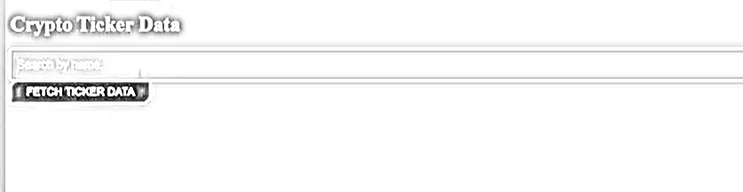

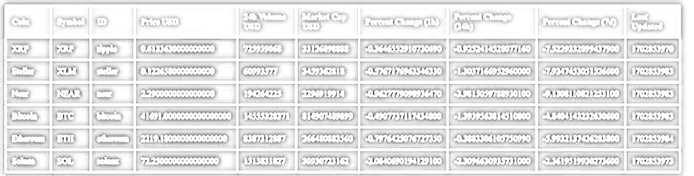

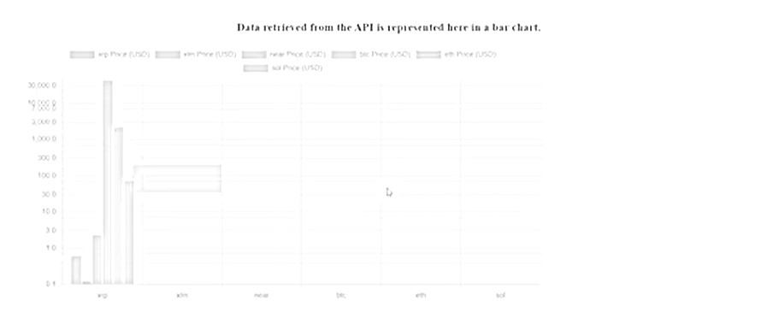

The users can retrieve the ID number for any cryptocurrency that exists in the crypto market.

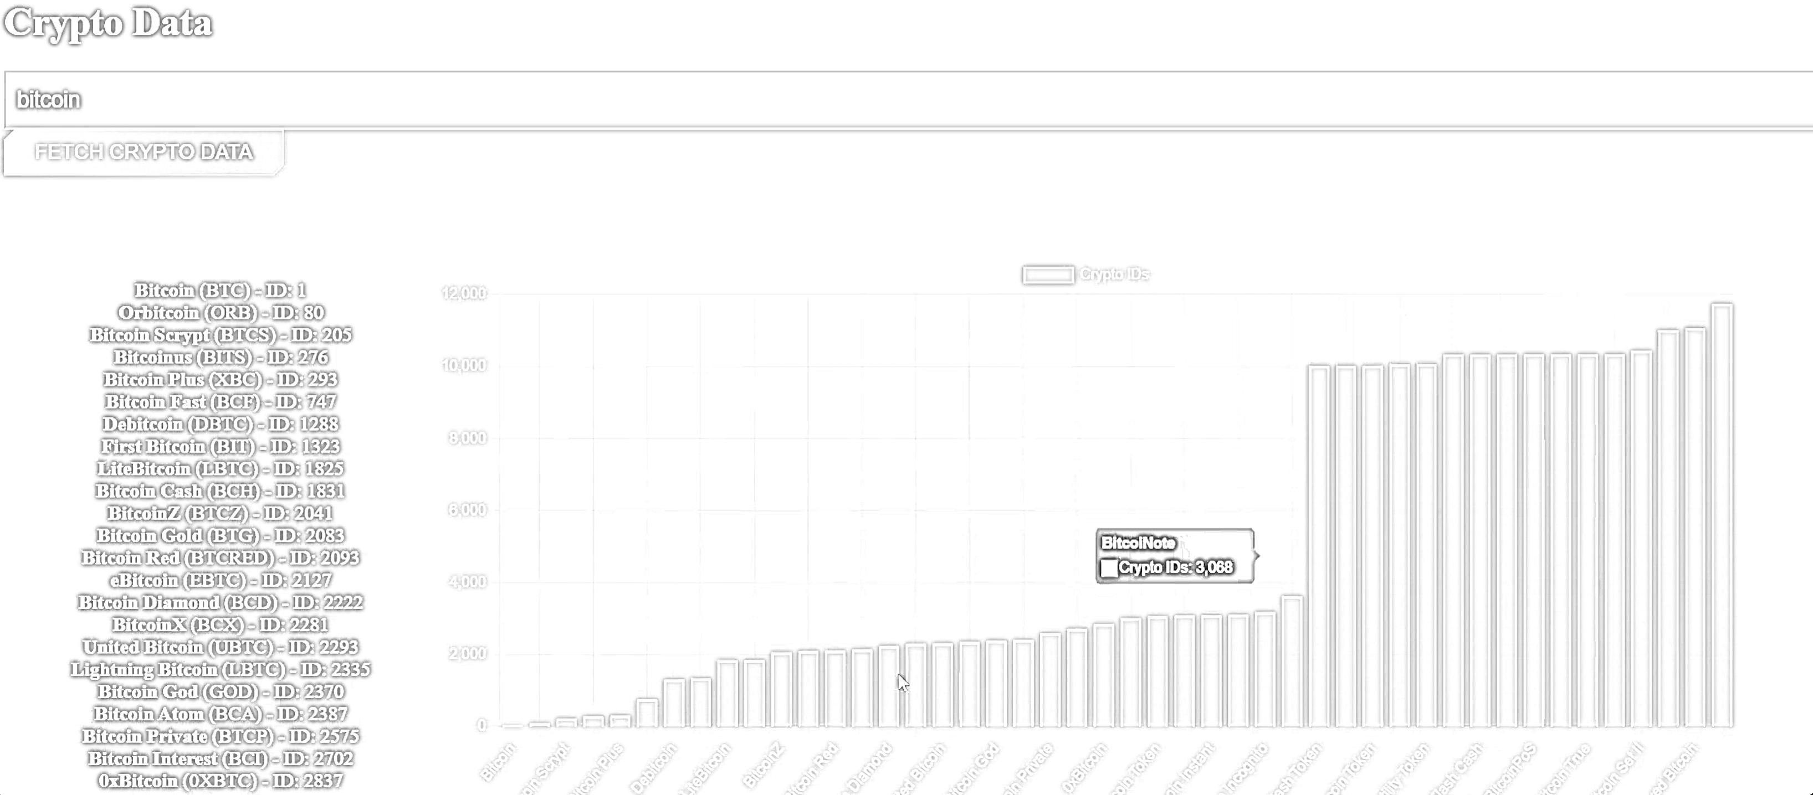

Fear and Greed index of the whole crypto market indicates. Integrating crypto bubbles frame by using API.

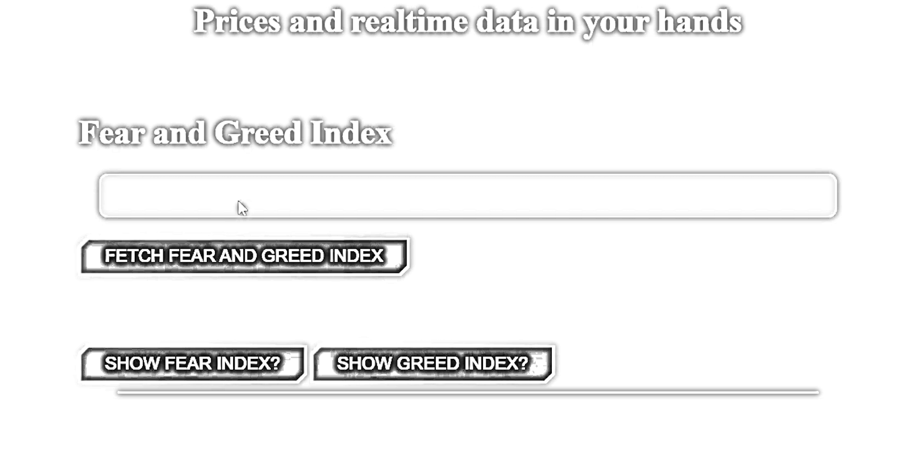

Users can see the frame of crypto bubbles from the webpage.

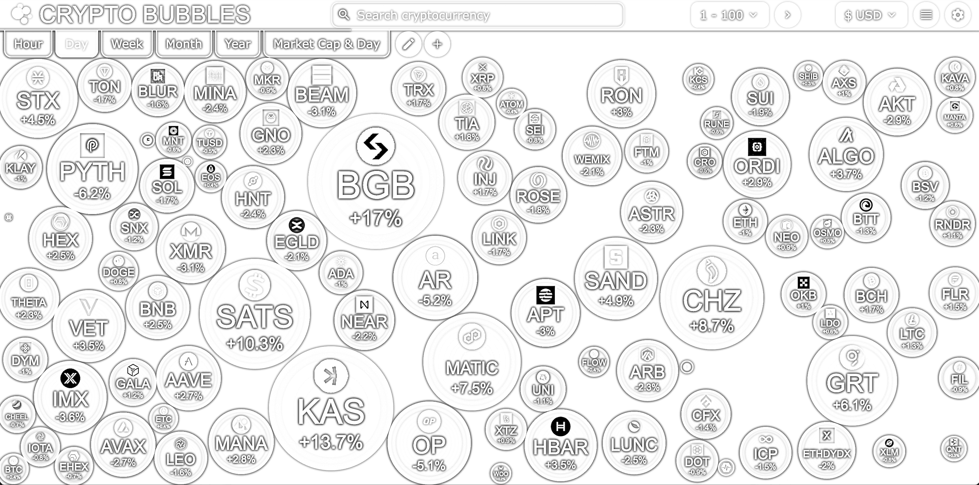

## Testing

We have done the black box testing on the project and white box testing while coding it along the way   
<https://github.com/EskandarAtrakchi/WebDev-project-2-NCI-Year-2/raw/main/WebDev%20API%20Test%20plan.xlsx>

This link will take you to excel sheet that shows the testing has been done on the pages.  
We have used excel to document the testing; however, we have not used the automated testing yet as we are coding in JavaScript not Java, we will do the automated testing as soon as we figure out how to automate JavaScript coded project working in harmony with multiple other languages and JavaScript libraries.

# Further Development

This project Develop a mobile version of the website for iOS and Android devices, which will providing users with access to cryptocurrency data and trading tools on the go through native mobile apps. In the future this project will Expand the website reach by adding support for multiple languages, making it accessible to users from different regions and language preferences.

With very impressive movements, this project can lead the development of trading digital financial assets, people can do make trading decision based on our website, considering that, this means we will lead millions of dollars in trading volumes if we make this correct!

# References

* NPM. (n.d.). chart.js. [online] Available at: <https://www.npmjs.com/package/chart.js?activeTab=readme> [Accessed 1 April 2024].
* NPM. (n.d.). cors. [online] Available at: <https://www.npmjs.com/package/cors> [Accessed 1 April 2024].
* Express. (n.d.). Installing Express. [online] Available at: <https://expressjs.com/en/starter/installing.html> [Accessed 1 April 2024].
* NPM. (n.d.). nodemon. [online] Available at: <https://www.npmjs.com/package/nodemon> [Accessed 1 April 2024].
* Axios. (n.d.). API Introduction. [online] Available at: <https://axios-http.com/docs/api_intro> [Accessed 1 April 2024].

# Appendices

This section should contain information that is supplementary to the main body of the report.

## Collaboration Summary

|  |  |  |
| --- | --- | --- |
| **Dev Name** | **Dev-Branch** | **Main** |
| [Eskandar-StudentNo.23137517](https://github.com/EskandarAtrakchi/Market-Live-Prices-Team-Project/tree/Eskandar-StudentNo.23137517) | <https://github.com/EskandarAtrakchi/Market-Live-Prices-Team-Project/commits/Eskandar-StudentNo.23137517> | <https://github.com/EskandarAtrakchi/Market-Live-Prices-Team-Project/commits?before=8ddff36abe9f142d5523d0cf325c0c2ac2a48077+35&author=EskandarAtrakchi> |
| [Alex-StudentNo.22440482](https://github.com/EskandarAtrakchi/Market-Live-Prices-Team-Project/tree/Alex-StudentNo.22440482) | <https://github.com/EskandarAtrakchi/Market-Live-Prices-Team-Project/commits/Alex-StudentNo.22440482> | <https://github.com/EskandarAtrakchi/Market-Live-Prices-Team-Project/commits/main?author=NCIAlexGar> |
| [Joshua-StudentNo.23153920](https://github.com/EskandarAtrakchi/Market-Live-Prices-Team-Project/tree/Joshua-StudentNo.23153920) | <https://github.com/EskandarAtrakchi/Market-Live-Prices-Team-Project/commits/Joshua-StudentNo.23153920> | <https://github.com/EskandarAtrakchi/Market-Live-Prices-Team-Project/commits/main/Joshua-StudentNo.23153920> |
| [Yonas-StudentNo.23154454](https://github.com/EskandarAtrakchi/Market-Live-Prices-Team-Project/tree/Yonas-StudentNo.23154454) | <https://github.com/EskandarAtrakchi/Market-Live-Prices-Team-Project/commits/Yonas-StudentNo.23154454> | <https://github.com/EskandarAtrakchi/Market-Live-Prices-Team-Project/commits/main?author=yonas255> |
| Overview | <https://github.com/EskandarAtrakchi/Market-Live-Prices-Team-Project/graphs/contributors> | | |

